|  |
| --- |
| 新东方在线英语学习 |
| 新概念 1 册 |
| Lesson139-140 |



扫一扫。更多有趣的英语资讯。

# Lesson 139 单词讲解

1. extra: adj. 额 外 的 ai ke si chu ao
2. extra work 额外的工作

加班：do some extra work

I have to do some extra work today. extra class 课外班

The boy has a lot of extra classes.

1. engineer: n.工程师an engineer
2. overseas: adj.海外的，国外的an overseas friend\company abroad, adv. 在国外

go\ study\ travel\ live abroad 4.engineering: n.工程

不可数

art\ music\ science\ chemistry… 5.company: n.公司

6.line: n.线路subway Line 13

subway Line 10

# Lesson 139 课文讲解

1. **电话用语**

**你是 Lucy 吗？Are you Lucy?**

**Is that Lucy?\ Is that you, Lucy?**

**我是 Venus. I’m Venus.**

**This is Venus. \ It’s Venus.**

**-Is that you, …?**

**-Yes, speaking. 是的，请讲。**

1. Tell Mary we'll be late for dinner this evening.

宾语

be late for…

He is late for class.

They were late for meeting yesterday. It’s time for…

It’s time for school.

It’s time for tea.

It’s time for dinner.

1. I'm afraid I don't understand.. I’m sorry…
2. Hasn't Mary told you? Has … told you?
3. I said I would be at your house at six o'clock.

宾语

1. … by the way, my wife wants to know if Mary needs any help.
   1. by the way: 顺便
   2. my wife wants to know if Mary needs any help.
   3. if, 是否
   4. 宾语从句的语序：

语序要改成陈述句 红色部分

Does Mary need any help? Mary needs any help.

1. I don't know what you're talking about.
   1. 宾语从句
   2. 引导词：what
   3. 语序：

What are you talking about? What you are talking about.

# Lesson 139 语法讲解

宾语从句

1. 什么是宾语从句： 句子作宾语。
2. 宾语从句的时态：
   1. 主句一般现在，从句任意时态
   2. 主句一般过去，从句相应过去
3. 语序：陈述句

他是医生吗？Is he a doctor?

我想知道他是医生吗.

I want to know if he is a doctor .

他们以前在北京吗？Were they in Beijing?

我想知道他们以前在北京吗.

I want to know .

他打算去吗？Will he go there?

我想知道他打算去吗.

I want to know if he will go there .

你看过这部电影吗？Have you watched the movie?

我想知道你看过这部电影没.

I want to know .

你喜欢红色吗？Do you like red?

我想知道你喜欢红色吗.

I want to know .

# 动词 + if +一般疑问句（陈述语序）

他昨天去上海了吗？Did he go to SH yesterday?

我想知道他昨天去上海了没.

I want to know .

他是谁？Who is he?

我想知道他是谁.

I want to know .

你昨天在哪？Where were you yesterday?

我想知道你昨天在哪.

I want to know .

他什么时候回来？When will he come back?

我想知道他什么时候回来.

I want to know .

你读过什么书？What books have you read?

我想知道你读过什么书.

I want to know .



他喜欢哪辆车？Which car does he like?

我想知道他喜欢哪辆车.

I want to know .

你喜欢什么礼物？What present do you like?

我想知道你喜欢什么礼物.

I want to know .

# 动词+引导词 +特殊疑问句（陈述语序）

1. 引导词：

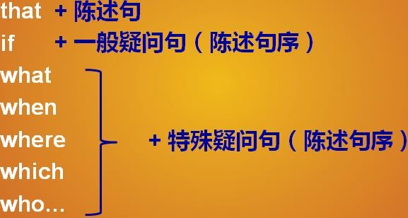

1. 如何识别宾语：

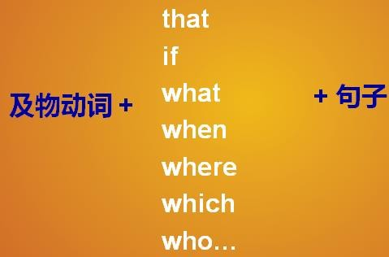

# Lesson 140 单词句型讲解

**Lesson 139&140 知识拓展**

宾语从句在口语中：

1. 我不知你在说什么。

I don’t know what you are talking about.

1. 我想知道你在说什么。

I want to know what you are talking about.

1. 我忘记早饭吃了什么。

I forget what I had for breakfast this morning.

